CoMa - User Guide

Running the Applet
Run the applet by loading the website:
http://www.cs.helsinki.fi/group/mindmap/coma/
Please reply "Yes" to the appearing Security pop up. CoMa will not harm your computer in any way. It only needs the permission to access your hard drive when saving a concept map file.
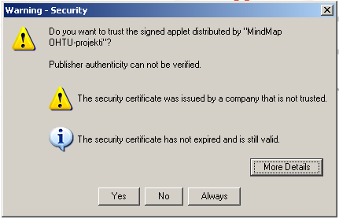

Functions

Creating a concept
Double-click the canvas or hit Enter, when no element is selected. You can also drag the connection icon of an element to a desired position on the canvas. This operation creates a new connected concept.
Connection icon

Creating a connection
Drag the connection icon of an element onto a concept or a connection. Note: A connection cannot be created between two connections.

Selecting elements
One or more elements close to each other can be selected with the mouse by drawing a square around the desired elements. Elements situated in different parts of the canvas can be selected by holding down the CTRL key while choosing the elements with the left mouse button.

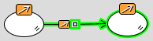 | The selected concept and connection

Naming the element
Create or select an element. Type the name by using the keyboard.

Removing an element
Select the element you wish to remove from the canvas and press the Del key or the Remove icon on the toolbar.
Remove

Commenting elements
Pick an element. Click the Comment icon on the toolbar. You can type or paste a comment or an URL address into the comment window.
Comment an element

Modifying the appearance of concepts
Pick a concept. You can modify the font size by dragging the size icon. The concept's shape, background color and name font can all be modified with the respectful menus on the toolbar.
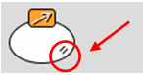 | Size icon
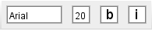 | Font  Font size  Bold  Italic
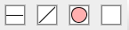 | Box border width  Box border style  Box shape  Box color

Modifying the appearance of connections
Pick a connection. The width and type of the line can be modified with the respectful menus on the toolbar.
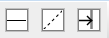 | Line width  Line style  Show arrowhead

Undo, Redo
Undo
Redo

Setting the element appearance as a default
Pick an element. Set its appearance as a default for new elements by clicking the Set as default icon on the toolbar.
 | Set the element appearance as a default

Modifying the Visibility of element icons
Open the Preferences menu. Select the option Hide element icons to make the icons visible only when moving the mouse cursor near an element.

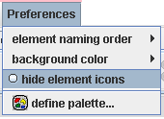

Naming order of concepts and connections
Open the Preferences menu. Check the order in which you wish to name the concept and connection when creating a connected concept.
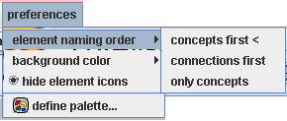

Saving the concept map
Press the Save icon on the toolbar. Enter a name for the concept map file and select the folder into which you wish to save it. Click "OK".
 | Save

Saving the concept map as an image
Select the option. Save as image from the File menu. Enter a name for the concept map and select the folder into which you wish to save the image. Click "OK".
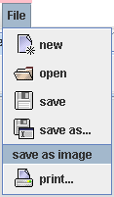

Printing the concept map
Select the Print function from the toolbar or from the File menu.
Print

Opening a concept map
Select the Open function from the toolbar or from the File menu.
Open a concept map from file

Creation of new concept map
Select the concept map creation function from the toolbar or from the File menu.
Create a new concept map

Have fun brainZtorming!!!!!!!

