DNA extraction from saliva and ACTN3 genotyping

Background
The α-actinins are actin-binding proteins encoded by a multigene family. In skeletal muscle they are the major structural component in the sarcomeric Z discs. Skeletal muscle isoforms are encoded by two genes, ACTN2 and ACTN3. ACTN2 is expressed in all skeletal muscle fibres, whereas expression of ACTN3 is limited to a subset of type 2 (fast) fibres. A common nonsense mutation in exon 15 of the α-actinin 3 gene (ACTN3), changing arginine to a stop codon at residue 577, results in ACTN3 deficiency in the general population. The mutation creates a novel DdeI restriction site. About 18 % of the normal human population is homozygous for the ACTN3 nonsense mutation. Interestingly, the ACTN3 genotypes show a correlation to athletic performance (Figure 1).

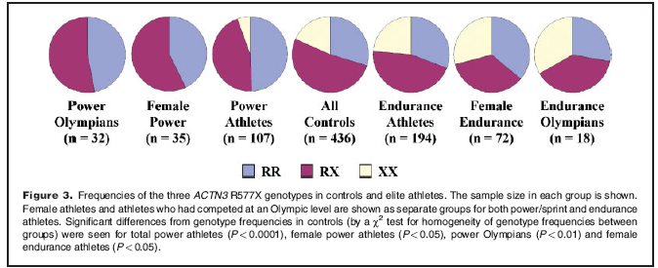
Figure 1. BioEssays 26:786–795, 2004.

Aim
To extract DNA from saliva with the Oragene DNA Self-Collection Kit (http://www.dnagenotek.com/), and determine the ACTN3 genotypes by DdeI digestion.

Procedure
- Collect and extract DNA from your own saliva. Follow the Oragene instructions.

Oragene TM DNA Self-Collection Kit

User Instructions:
• Before spitting, please rinse your mouth with water to get rid of food particles. Then wait at least 1 minute before spitting your sample.
• Finish spitting within 30 minutes.

Splitting:

- Slit your saliva into the Oragene container
- Stop when the amount of the saliva reaches the top of the white label.
- Tighten the cap very firmly
- Gently mix your saliva

Purification of DNA from saliva

DNA yield and stability in OrageneTM
Oragene yields a large amount of DNA from saliva. The median yield from 4 mL of Oragene/saliva solution is 110μg, with a 25th percentile yield of 62 μg and a 75th percentile of 158 μg. When saliva is mixed with Oragene, the DNA is immediately stabilized. Oragene/saliva samples are stable at room temperature for years without any processing. Alternatively, the samples may be stored at -20°C if this is more convenient. Oragene/saliva samples may undergo multiple freeze-thaw cycles without any degradation.

Equipment and reagents to be supplied by user
• Microcentrifuge capable of running at 15,000 × g (13,000 rpm)
• Water bath or air incubator, heated to 50°C
• Ethanol (95 to 100%) at room temperature
• TE buffer (10 mM Tris-HCl, 1mM EDTA, pH 8.0) or other standard buffer

DNA purification steps

DNA may be purifi ed from the total 4 mL sample.
1. Incubate the Oragene/saliva sample in the Oragene vial at 50°C in a water bath over night.

2. Divide the total 4 mL Oragene/saliva sample into four 1.5 mL microcentrifuge tubes, each
containing approximately 1 mL of sample.

3. Add 40 μL (1/25th volume) of Oragene Purifier (supplied with kit) to each tube and mix gently
by inversion. The sample will become turbid as impurities are precipitated.

4. Incubate the four tubes on ice for 10 minutes.

5. Centrifuge the four tubes for 3 minutes at 15,000 × g (13,000 rpm) at room temperature. Carefully
pipet the clear supernatant from each tube and combine them all into one 15 mL centrifuge tube
without disturbing the pellets. Discard the pellets.

6. Add 4 mL (equal volume) of room-temperature 95% ethanol to the supernatant and mix gently by
inversion. Invert at least 5 times. A clot of DNA may be visible.

7. Let the solution stand for 10 minutes at room temperature so that the DNA is fully precipitated. Do
not incubate at -20°C because impurities may co-precipitate with the DNA.

8. Centrifuge for 10 minutes at 1,100 × g (3,500 rpm) at room temperature.

9. Discard the supernatant without disturbing the DNA pellet (may or may not be visible). Remove
ethanol as thoroughly as possible.
10. Once all of the ethanol has been removed, dissolve the DNA pellet in 500 μL of TE or other
standard buffer. The expected concentration of the rehydrated DNA is 20 to 200 ng/μL.

11. To fully dissolve the DNA, we recommend vigorous vortexing followed by incubation for a
minimum of 1 hour at room temperature, preferably overnight. Alternatively, incubation for 10
minutes at 50°C is also effective.

Quantification of DNA

Quantification by absorbance is accurate enough for PCR and most downstream applications, but quantification by fluorescence is preferred. To ensure accuracy, absorbance readings at 260 nm should fall between 0.1 and 1.0. The sample dilution should be adjusted accordingly. Absorbance at 320 nm (A320) measures light scattering and gives an estimate of the background turbidity. A high A320 reading results in artificially high estimates of yield (A260) but also reduces estimated DNA purity (A260/A280). Many spectrophotometers will automatically subtract the A320 reading from the A260 and A280 values. DNA from Oragene should have an A260/A280 ratio > 1.6.

Measure the concentration of DNA by taking 2.0 µl of the sample and 98.0 µl of water (dilution 1:50). Measure the diluted sample in spectrophotometer. Ask for help if needed.

- Perform the PCR as follows: (make 3X mix; 2 for your own DNA, 1 for water control)

PCR reaction (1x), 35 µl
3.5 µl EXT buffer including 15 mM MgCl2
2.0 µl 10mM (2.5 mM each) dNTPs
0.4 µl ACTNlongF (20 µM)
0.4 µl ACTNlongR (20 µM)
0.4 µl Dynazyme EXT
25.3 µl water
3.0 µl DNA

PCR-programme (LONG)(claes)
    - 94 °C, 5 min
    - 94 °C, 1 min
    - 59 °C, 1 min
    - 72 °C, 30 s
    - 2 to 4, 29 cycles (34 cycles)
    - 94 °C, 1 min
    - 59 °C , 1 min
    - 72 °C, 5 min
    - 4 °C, hold

- Check 5 μl of the PCR reaction on an 1.5 % agarose gel, the correct product size is 678 bp

1.5 % agarose gel
Measure 1.5 g agarose with 100 ml 1xTAE. The mixture is heated in a microwave over until the agarose is completely dissolved and solution clear. After cooling solution to about 60 °C, 2 drops of ethidium bromide is added. The gel solution is then poured into a casting tray containing a sample comp. The gel is allowed to solidify at the room temperature (less than 30 minutes).

To prepare samples for electrophoresis
- Take 5 μl of the PCR product to the new tube and add 5 μl water (MQ) and 2 μl of 6x loading dye and mix carefully.
- Remove the comb from the gel and gel is put into a electrophoresis chamber and filled with 1x TAE buffer.
- The sample (from the step 1.) is loaded to a well in a gel. Also the DNA ladder is loaded in order to estimate the size of the fragment in the gel.
- The Electrophoresis is performed at 100 volts for about 30 minutes to check the correct size of the PCR product.

- Digest the PCR-product as follows:

Dde1 Digestion (20 µl) on ice
16 µl PCR product
2 µl Buffer 3
2 µl Dde1 enzyme

+ 37 ºC over night

- Run the digestions on 1.5 % agarose gels. Analyse the results.
  - Wild type sequence(r,r): 188 and 485 bp products
  - Mutant sequence(x,x): 100, 188 and 385 bp products

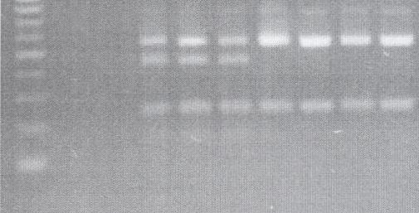
485 bp
100 bp
385 bp
188 bp
r/x (wt/mut)
r/r (wt/wt)

