University of Helsinki
Department of Computer Science

Software Engineering Project Perf+
User Manual

Kirsi Elo-Holma
Juhani Snellman

Timo Tapanainen
Laura Väisänen

12.12.2002
Version history

Version | Date | Comment | Authors
1.0 | 31.05.2002 | The first version | Aija Airaksinen  Eevaliisa Colb  Hannele Hakkarainen  Saara Nygren  Tuula Summanen  Petteri Susi
2.0 | 28.11.2002 | The updated version | Kirsi Elo-Holma  Juhani Snellman  Timo Tapanainen  Laura Väisänen
2.1 | 12.12.2002 | The version, that has been corrected after the FTR and chapter 4 has been updated | Kirsi Elo-Holma  Juhani Snellman  Timo Tapanainen  Laura Väisänen

Contents

1. Introduction 1
2. Making a memory usage estimation 1
2.1. Settings 2
2.2. Results 3
3. Editing class/object sizes and attribute type sizes 4
3.1. Class sizes 4
3.2. Attribute type sizes 5
4. Selection an execution path from an activity diagram 7

1. Introduction

Perf is the memory usage estimating part of Maisa. The estimations it makes are based on UML diagrams that represent the programme being analysed. UML diagrams that are used are class diagrams, activity diagrams and collaboration diagrams. An activity diagram can be associated with one or more class diagrams and a class diagram with one ore more activity diagrams. In addition, there may be sub-activity diagrams in the nodes of activity diagrams.

Three kinds of execution paths can be found from the graphs:
- The shortest path is the one that has the smallest lower bounded memory usage estimate.
- The longest path is the one that has the biggest upper bounded memory usage estimate.
- The typical path is the one that is most probable. A probability is calculated for each execution path.

Perf can make three interesting estimates regarding memory usage for each of these paths. Depending on the settings made by the user, the result can contain one or more of the following kinds of estimates [ZHE01]:
- The lower bounded memory usage estimate takes into account only the objects created on the heap.
- The upper bounded memory usage estimate is calculated assuming no created objects are ever destroyed during the execution of the programme.
- The combined memory usage estimate is made taking into account the static objects, heap objects and stack objects. Thus it is made of both heap- and non-heap objects.

2. Making a memory usage estimation

A memory usage estimation for an activity diagram can be made as follows: open a project by selecting File – Open – Project/Diagram in Maisa's main window. A project is a directory where all its files (diagrams) are stored. You can also open all the necessary diagrams that are needed for the calculation separately. The necessary diagrams for a calculation are one activity diagram, one or more collaboration diagrams and one or more class diagrams. Next you must select the measures and metrics that you want calculated. This is explained in section 2.1. Also default files for user defined class sizes and attribute type sizes are needed for a calculation. Creating these is explained in chapter 3. Once created and set, the default size files are there so the steps for creating and setting them need not necessarily be taken again. Finally, the calculation is started by selecting an activity diagram from the diagram list and then selecting Run – Measure in Maisa's main window.

In order to find the typical path, the activity diagram and the collaboration and sequence diagrams must contain the information necessary to calculate the probability of each of the execution paths. This means that the probabilities attached to the transitions must be greater than zero but no greater than one and that the combined probability of the transitions from one node must be equal to one. Also, there can be only one transition from one node for which the probability is not defined. This kind of transition’s probability is assumed to be the remainder of the combined probability of the other transitions from the node. The value of this probability must be greater than zero, too. And, finally, the typical numbers of repetitions attached to the loops of the diagrams must not be less than zero. If there is only one path in the diagrams, the information on the transitions’ probabilities is not obligatory in order to make memory usage estimations. In MAISA and Perf there isn’t possible to edit the probabilities attached to the transitions or the typical numbers of repetitions attached to the loops of the diagrams. This information have to be set by the user during creating the diagrams.

2.1. Settings

Selection of the paths to be found and the estimates to be calculated for each path is made by ticking the appropriate boxes in the Measures Et Metrics –window. The user can also enable tracking of memory threshold underflows and overflows. The tracking is enabled by ticking appropriate memory estimate types and inserting lower and upper thresholds (Fig.2.1.). The types of threshold values can be integer or decimal numbers.

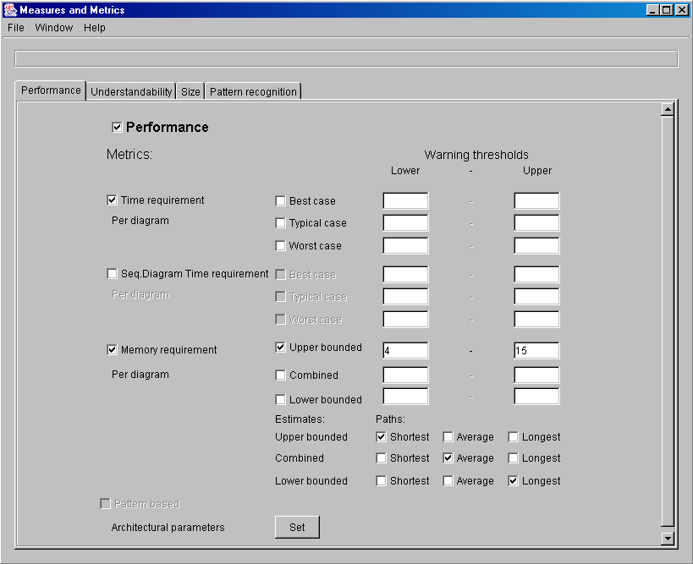

Figure 2.1. Measures Et Metrics -window.

2.2. Results

The results of the calculation are displayed in Maisa’s main window. According to the settings made by the user before starting the calculation the wanted metrics are displayed in textual format after the measurement. Threshold related results are also displayed in the Maisa’s main window.

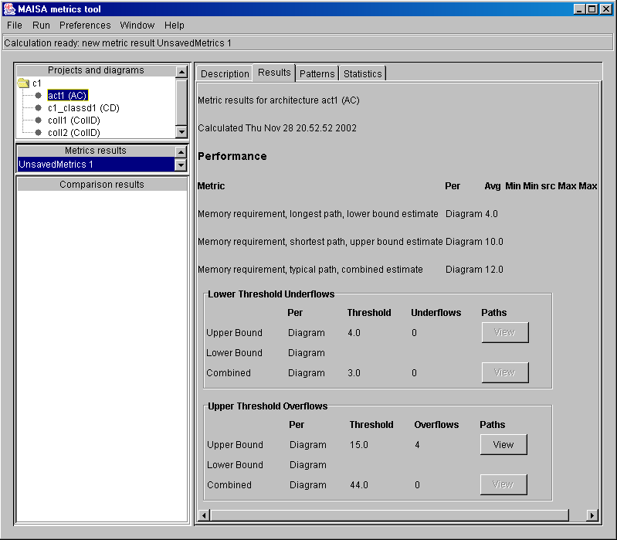

Figure 2.2. Maisa’s main window. Results tab selected.

In figure 2.2. there is Maisa’s main window, where threshold results are grouped into two sections. First contains threshold underflows and second threshold overflows. Threshold column contains threshold values set in Measures Et Metrics –window. Underflows / overflows column contain the amount of detected underflows / overflows. Paths column contain buttons for viewing detected paths. If underflows / overflows have been detected during the calculation, the detected paths (Fig. 2.3.) will be viewed after selecting the ‘View’ button.

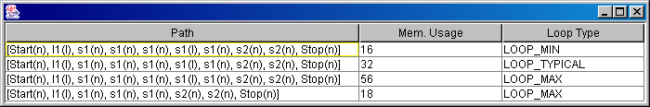

Figure 2.3. View of detected paths.

3. Editing class/object sizes and attribute type sizes

Class and attribute sizes of can be edited in a separate window that can be opened by right-clicking said diagram in the project list, and selecting ‘Edit sizes’. The window that opens has two tabs – one for editing class sizes (the sizes for whole classes) and additional sizes given to classes (used when calculating the size of the class from its fields), and one for editing attribute type sizes.

3.1. Class sizes

The tab for class sizes has a table where the sizes are displayed, a menu for selecting the size info file that is opened for editing and buttons for the functionality of the window.

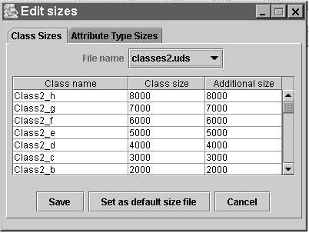

Figure 3.1. The window for editing class sizes.

Opening a size file for editing

When the window opens, the size info from the default class size file (defined in preferences) is displayed in the table. The drop-down file menu can be used to select a file that is wanted for editing. Once the file is chosen from the menu, the size information is displayed in the table.

Editing sizes

The sizes can be edited in the table by selecting a cell and then typing. The names of the classes should not be edited, because then the collection of classes does not represent the diagram it was created for anymore. However, you can create new size information files where you add the classes yourself if needed.

Saving changes

The changes can be saved by pressing the ‘Save’-button. If a new file is being created, the user is prompted for a file name to be used for saving the size information.

Creating a new size file

A new size file can be created by first selecting ‘<new class file>’ from the file menu, which clears the table, and then typing classes and their sizes in the table. You can also leave the table empty. When the sizes are ready, the new file can be saved by pressing ‘Save’, which opens a pop-up window where the user is prompted for a name for the file. If a name of an already existing file is given, the old file will be overwritten.

Setting the default class size file

The class size file that is currently displayed can be set as the default class size file by pressing the ‘Set as default’-button.

3.2. Attribute type sizes

The ‘Attribute Type Sizes’-tab similarly has a table of sizes. Size information from the default attribute type size file is displayed when the window is opened. New attribute type size files can be created by the user, but new attributes cannot be added by hand. Perf adds these to the default file when it finds new attribute types during calculation.

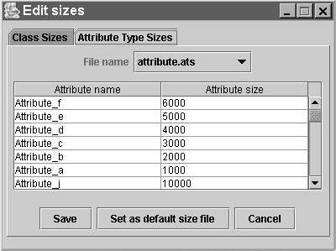

Figure 3.2. The window for editing attribute type sizes.

Opening a size file for editing

See 3.1.

Editing sizes

See 3.1. You cannot add attributes by hand, Perf adds them to files. If you enter size information to the table without attribute names, it will be ignored when saving. The column for attribute names is not editable.

Saving changes

The changes can be saved by clicking the ‘Save’-button.

Creating a new size file

You can create a new attribute type size file by selecting ‘<new attribute file>’ from the file menu. You cannot add any attributes or their sizes in it, because these are added by Perf when it is traversing the graphs while performing calculations and comes across an attribute type which is not yet in the default attribute type size file.

Setting the default attribute type size file

The file that is currently displayed can be set as the default file for attribute type sizes by clicking the ‘Set as default’-button.

4. Selection an execution path from an activity diagram

The user can choose an execution path from an activity diagram by selecting the diagram and choosing ‘Select Execution Path’ from the menu Windows (Fig 4.1.).

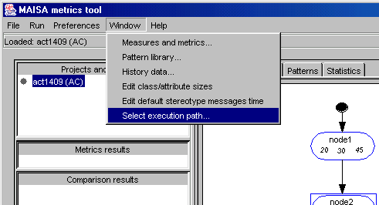
Figure 4.1. Activity diagram is selected, and the option ‘Select execution path…” can be selected from the
menu.

In the selection window (Fig 4.2.) the user can see the name of the current node and a dropdown list that contains the possible next nodes i.e. the nodes that the current node has a transition to. Nodes can be added to the execution path by choosing the node from the list and clicking the Add Node button. When a stop node is added to the execution path, the Finish button is enabled, and the user can now approve the selection and continue.

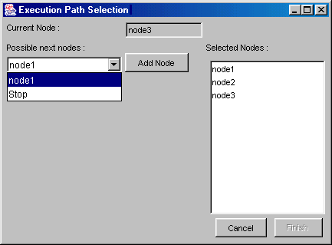Figure 4.2. The Execution Path Selection –window

After selecting the path it will appear in the Projects and Diagrams list in the Maisa –tool’s main window. Now the diagram containing the selected execution path can be selected in the same way as a normal diagram, and the measurements can be run agaist it in a similar fashion as with other activity diagrams.
References

ZHE01 Zheng, Hui, Runtime Memory Usage Estimation from UML diagrams, Master's thesis in Computer Science, University of Helsinki, 2001, series of publications C-2001-21.

