582497 Operating Systems, 1. course exam 19.10.2006
Please write on each paper the date and the name of the course as well as your name, student id (or social security number) and signature. Try to keep your answers short. Concentrate on the essential and fundamental parts.
The exam time is 2,5 hours and there all 24 points available in the exam.

- PROCESSES AND THREADS (9 points)
Observe Solaris processes and threads (see Fig 4.15 below). Consider two applications: M and K. Each of them has 8 threads within the process. Application M is of type 3 (with 3 L-threads) and application K of type 4(with 8 L-threads). Assume that the system has 4 processors. Assume also that only one of the applications (either M or K) is executed in the system at any given time. That is the applications are not executed concurrently.
  - [3p] Explain briefly (with the help of the figure) what do the following terms mean:
    - ULT (User Level Thread)
    - LWP (Light Weight Process)
    - KLT (Kernel Level Thread)
  - [3p] How many threads can in each case (application M and K) be executing concurrently in machine language level? Justify. Give answers separately to applications M and K.
  - [3p] If an executing thread will block because of I/O, will the application (M or K) block or not? Justify. Give answers separately to applications M and K.
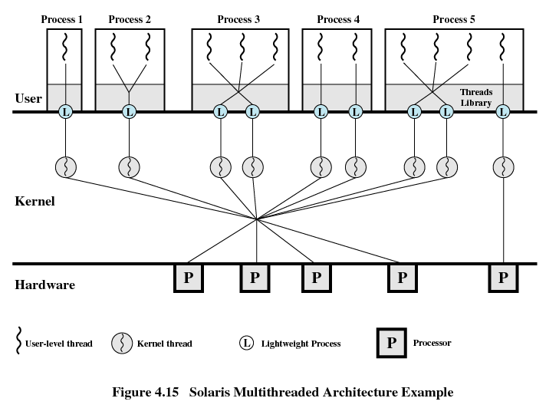

- MEMORY MANAGEMENT (6 points)
The memory configuration (of 512 megabytes of memory) at a given point in time is:
32M | 48M (A) | 48M | 128M (B) | 16M | 16M (C) | 64M | 160M (D)

The shaded areas are allocated; the white areas are free. Additionally, the free areas are marked with letters after their sizes. The next five memory requests are for
50M, 24M, 10M, 60M, 30M
Indicate the location for each of the requests, when the memory allocation is based on
  - [2p] a dynamic partitioning scheme and first-fit placement algorithm,
  - [2p] a dynamic partitioning scheme and best-fit placement algorithm,
  - [2p] Buddy System.

- VIRTUAL MEMORY (9 points)
  - [3p] Please explain in details, what are the components of the Memory Management Unit (MMU) and how does it do address translations, when the system is based on paging virtual memory.
  - [3p] Explain how does the clock-algorithm operate. What will be the target page frame for a new page, if the clock algorithm is used in the situation given in the table below (the process has only 4 page frames). The times are clock-ticks from the beginning of the process.
Sivu#  (page number) | Sivutila#  (page frame) | Latausaika  (Time loaded) | Viittausaika  (Time referenced) | R | M
2 | 0 | 60 | 121 | 0 | 1
1 | 1 | 130 | 120 | 0 | 0
0 | 2 | 26 | 122 | 1 | 0
3 | 3 | 20 | 123 | 1 | 1

  - [3p] The execution of the process continues and generates the following page reference string:
4, 0, 0, 2, 1, 5, 4, 5, 0, 3, 2
How many page faults would occur if the working set policy were used with a window size 4 instead of the fixed allocation? Show clearly which pages form the current working set and when each page fault would occur.

