H E L S I N G I N Y L I O P I S T O 581365
Matem.-luonnontiet. tiedekunta Computer Organisation II
Tietojenkäsittelytieteen laitos
Separate Exam
Auvo Häkkinen 25.01.2005
_____________________________________________________________________

Please write on each paper the date and the name of the course as well as your name and signature.

1. CACHE (15p)

- What is there common / different with cache and TLB? How do they relate to each other? What does the concept "split cache" mean? How is that related to TLB? (6p)

Assume, that the system using (unrealistically) small cache memory refers to a 4-byte word using the byte address 0xA0B1 (i.e. the address is 16 bits long). Assume that the cache line size is 16 bytes and the cache size is 256 bytes.

Draw figures and explain how the solution finds the above-mentioned byte from the cache, when the implementation is based on
- fully associative mapping (4p)
- 2-way set associative mapping (5p)

In both cases, show clearly how the byte address is divided into separate fields used by the implementation. You may assume that the referenced data is found in the cache.

2. DEPENDENCIES (15p)

Assume that in RISC architecture ALU instructions have three register operands and that the result is stored into the first register. Observe the following set of instructions

01: Load R2,VarX ; Regs(R2) <- Mem(VarX)
02: Add R5,R5,R2 ; Regs(R5) <- Regs(R5) + Regs(R2)
03: Move R2,R6 ; Regs(R2) <- Regs(R6)
04: Add R3,R3,R2
05: Mul R3,R2,R5
06: Jnzer R2,Loop
07: Add R3,R2,R5

- Assume that the architecture is implemented in ordinary (not superscalar) pipelined fashion so that, in best case, one instruction can be completed in each cycle. Describe precisely the problem types known as data dependency, structural dependency and control dependency, and show in a clear way all occurrences of each problem type in the given piece of code. How can one avoid or reduce the performance problems caused by each problem type? (9p)

- Assume now, that the architecture is implemented as superscalar. Describe precisely new problem types known as output dependency and antidependency, and show in a clear way all occurrences for each problem type in the preceding code segment. How can one avoid or reduce the performance problems caused by each new problem type? (6 p)

3. MICROPROGRAMMED CONTROL (15p)

- What “problem” is solved with the microprogrammed control? (2 p)
- How is microprogrammed control implemented? (5 p)
- Explain briefly three ways to produce the next microprogram control address into Control Address Register, CAR. (3 p)
- How is the interrupt handling implemented with the microprogrammed control? (2 p)
- What advantages/disadvantages does the microprogrammed control have as compared to hardwired control? (3p)

4. COMBINATORIAL CIRCUIT (15p)

A combinatorial circuit is used to control a 7-segment display. The circuit has 4 inputs (x1, …, x4) and seven outputs (z1, …, z7). The circuit gets a BCD-coded number as an input. Thus the input is represented by a 4-bit code, and numbers 0, 1, 2, ..., 9 are coded as 0000, 0001, 0010, ..., 1001. The circuit is used to activate appropriate segments in the display to show the given number on the display. When an output is active (gives out value 1), the corresponding segment is lighted.

- Give the truth table for producing the result for all outputs. (3p)
- Give a Boolean expression in sum of products form (SOP) for the output Z4. (3p)
- Give a Boolean expression in product of sums form (POS) for the output Z4. (3p)
- Give the Karnaugh map for the output Z4, and give the simplest Boolean expression for the output Z4. (4p)

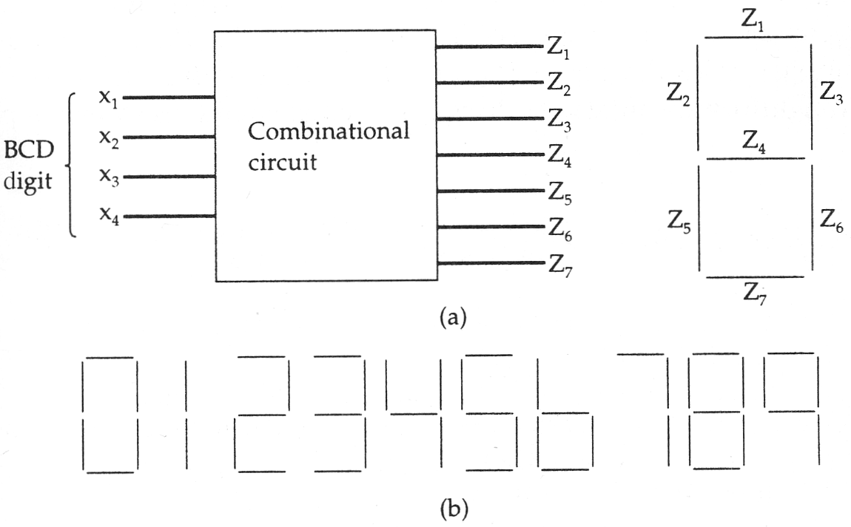

Opiskelu on asenne, ei olotila. Aatteleppa ite.

