Appendix A

Component names with pictures
- Schedule
- Timeline
- Calendar Scrollbar

- Schedule:
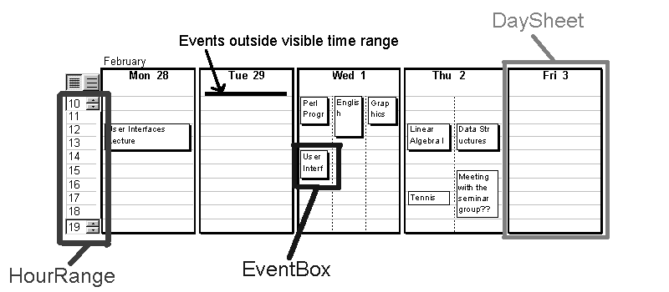
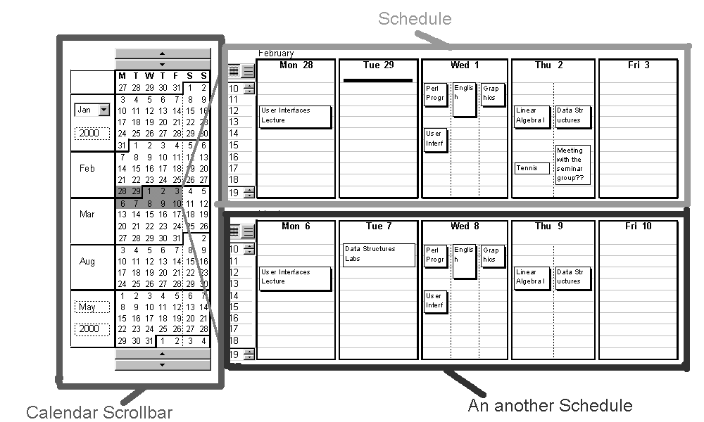
- Timeline:
- Calendar Scrollbar:

