Schedule and TimeLine Java Bean Components
Tide project

Requirements Specification
Version 1.1

Panu Hiltunen Päivi Kero Jussi Laukkanen Teemu Kurppa

University of Helsinki
Department of Computer Science
Software Engineering Lab

Instructors:
Asko Saura
Karri-Pekka Laakso

Helsinki 30.9.1999

Contents
1 Introduction (JL) 3
1.1 Purpose 3
1.2 Definitions and Acronyms 3
2 User Interface Design Patterns Schedule & Timeline (JL) 4
2.1 Schedule 4
2.2 Timeline 4
3 Use Cases 5
3.1 Student Calendar (PK) 5
3.2 Lecture Room Booking System (TK) 6
3.3 Team Calendar (JL) 8
3.4 CageMaker (PH) 9
4 User Interface Requirements (TK) 10
4.1 Schedule 10
4.2 Timeline 12
5 Implementations Requirements (PH) 13
6 Specific Requirements (JL) 14
6.1 Documentation 14
7 Testing Requirements (TK) 14
7.1 Test phases & timing 14
7.2 User Interface Testing 14
7.3 API Testing 15
7.4 Module Testing 15
7.5 Integration and System Testing 16
7.7 Java Bean Compatibility Testing 16
7.8 Usability Testing 16
8 References 17
9 Document Versions 17

1 Introduction (JL)

1.1 Purpose
Many of the successful and unsuccessful user interface solutions are continuously reinvented and reimplemented. Both the design and implementation are often created from scratch or copied blindly from existing applications by inexperienced designers or programmers. In addition to waste of time and effort, this leads to low-quality design, which is difficult to document [1].

Tide is a one-term project (fall 1999) in the Department of Computer Science, University of Helsinki, which designs and implements reusable Java user interface components. Tide is a part of the research of User Interface Design Patterns as reusable Java Beans, done by the Department of Computer Science

Tide designs and implements two reuseable Java Bean components: Schedule and Timeline, which with their high quality user interface design and exceptional reusability, can be referred as user interface design patterns and used to reduce problems of the kind mentioned above. As Java Beans, the components are easily used in any user interface management system (UIMS) for Java.

The client of the Tide project is Assistant professor Sari A. Laakso from the Department of Computer Science.

The work description of the project is included as appendix B (in Finnish).

1.2 Definitions and Acronyms
UIMS = User Interface Management System

2 User Interface Design Patterns Schedule & Timeline (JL)

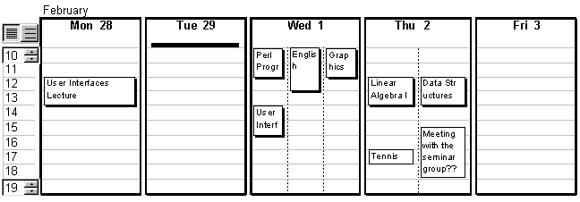
2.1 Schedule
Figure 2.1 Schedule [1]
Schedule is a flexible calendar view that can be intuitively and directly manipulated by the user. Schedule pattern design emphasizes maximal visibility and direct manipulation of events and the time range: everything can be edited in place. In the design, special care has been taken in solving the problem of showing simultanious events. Drag and drop of event objects is also supported.

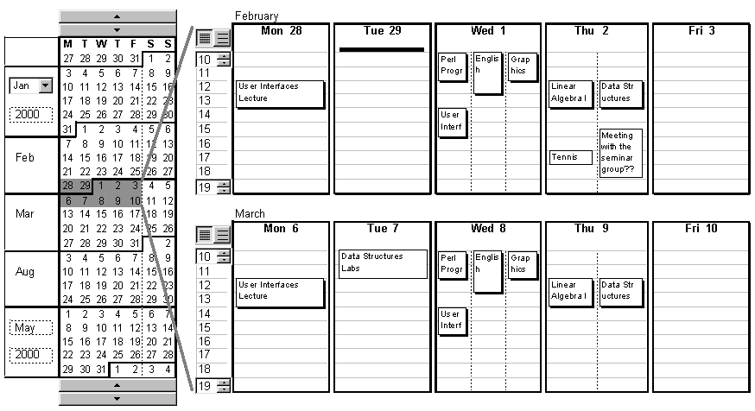
2.2 Timeline
Figure 2.2 Timeline [1]
Timeline introduces an advanced scrollbar in order to manage time intervals. Timeline takes advantage of the Schedule Java Bean in order to display time intervals selected by the user. Timeline works best with short time slices, up to six months.
The thumb of the Timeline scrollbar (the dark grey rectangular area in fig 2.2) can be dragged with the mouse to another position. The size of the thumb (corresponds to displayed time interval in Schedule view(s)) can be directly incresed or decreased by dragging its borders with the mouse.

The user is able to change the range (number of months displayed) of the Timeline scrollbar by editing the months and years in the ends of the scrollbar.

3 Use Cases

3.1 Student Calendar (PK)
Student calendar is a calendar that can be used by a student to plan and manage her schedule. An example of student’s schedule can be seen in picture 2.1.

- I have Linear Algebra I lectures on Thursdays 12-14 and I want to put them in my calendar for the whole semester.
- I usually wake up late in the morning so I don’t usually need to see my what’s in my calendar before 10 am.
- I want to put Data Structures lectures, which are on Thursdays at the same time as Linear Algebra I lectures, in my calendar.
- I notice that there is something in my calendar next Tuesday early in the morning and I’d like to see quickly what it is.
- My friend has found a new job and we want to go out and celebrate it so I need to see next three weeks in my calendar including weekends.
- My cousin has a birthday in two months. I wonder if I have put that in my calendar already.
- Next weeks User Interfaces lecture has been cancelled.
- This week User Interfaces lecture will last an hour longer because next weeks lecture was cancelled.
- My friend got married one month ago and I want to put the wedding day in my calendar so I will remember to congratulate her next year.
- We have been talking about going on a cruise with friends and I need to see if there are any weekends free during next couple of months.
- Meeting with the seminar group on Thursday 15.30 is very important.
- There is usually a lot of action on Thursdays so I’d like it if there were more room for my markings on that day.
- I want to see three Wednesdays, which are not on sequential weeks because a meeting must be scheduled on one of them.
- I have a project meeting on 14th Tuesday and I need a lot of material with me so I’d like to put the meeting and a list of the material as a reminder in my calendar.
- It’s Tuesday and I need to see the list of everything I need so I can be sure I have everything with me.
- Thursday’s seminar group meeting has been moved to Friday 14.00.
- I promised to go and visit my grandparents on Saturday afternoon.
- There is another seminar group meeting two weeks from now on Tuesday, but was it at 13.00 or 14.00?

3.2 Lecture Room Booking System (TK)
Lecture Room Booking System is used to plan and schedule bookings of rooms in Department of Computer Science. Department has tens of practice and lecture rooms, and on the other hand tens of simulatenous lectures and practice sessions with different needs related to rooms. In addition to weekly events such as lectures, guest talks, conferences, workshops etc. needs appropriate spaces.
Typical user of Lecture Room Booking System is an amanuensis of Department of Computer Science.

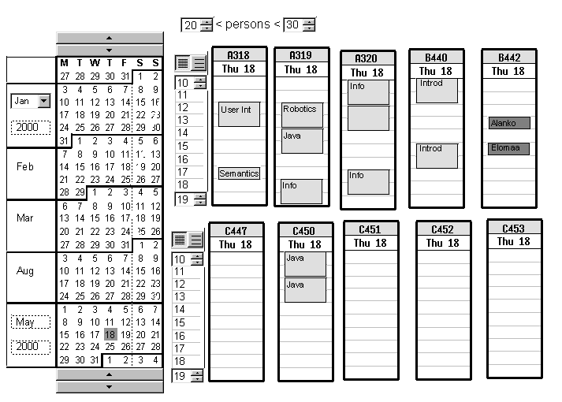
Figure 3.1 Lecture Room Booking System
- Lectures on Data Structures are given at Tuesdays 14-16 and Thursdays 14-16. The amanuensis wants to book those times in Auditorium for the whole fall semester (weeks 37 – 48).
- The amanuensis wants to book a big enough room for lectures on Artificial Intelligence given at Mondays 12-14 and Thursdays 14-16. Again, lectures are given throughout the whole fall semester.
- The working day of amanuensis is about to end. All practice rooms are booked at Wednesdays 12-14, but still two practice groups are missing the appropriate room. The amanuensis decides to solve problem tomorrow, but how can she remember the conflict.
- There’s surprising interest in Perl programming and over 200 people have entered for Perl programming course. The size of exercise groups is raised from 20 to 30. Some groups originally scheduled to meet in small rooms have to be moved to bigger ones.
- Students have complained that there is not enough practice groups of Java Programming at Fridays. One practice group is moved from Wednesday morning to Friday.
- The amanuensis books Tuesdays at 10-12 in room A516 for Computer graphics course for the whole fall semester. But room A516 is already booked for international workshop on Autonomous Agents during the weeks 39 and 40.
- The amanuensis starts to schedule room bookings for fall semester. Lecture times are mainly known in advance, because lecturers have had the opportunity to propose times best suited them. The amanuensis wants first to book rooms for lectures day by day.
- Lecturer Elomaa is ill and all his lectures are cancelled for the next two weeks.
- A famous researcher of pattern matching is visiting the Department. He would like to give a talk on his subject at Tuesday 16.11. A room big enough should be found for the talk.
- Two rooms are needed for week 44 for Nordic Workshop on Tele Communications. Which two are least used during that week?
- Participants of User Interface II have decided to give up lecture on Fridays 12-14 and extend lectures at Wednesdays (originally at 12-14 in room A414) to three hours. However, in the same room there’s lectures on Semantic of Programming at 10-12, but from 14 onwards the room is free.

3.3 Team Calendar (JL)
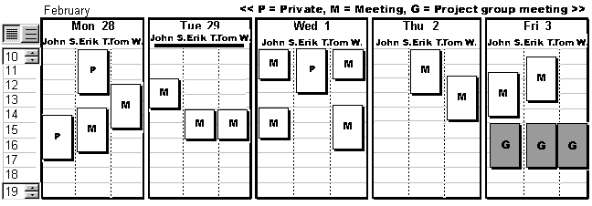
Typical user of Team Calendar is a small team of engineers working on some project.
Figure 3.2 Team Calendar

- A small software engineering team, consisting of 5 members is assigned to a new project. In order to reserve times to meetings, the project leader asks all the members of the team to mark their schedules in the same calendar. The schedule of each team member is displayed simultaneously in the calendar view. The project leader has then an easy task to find common suitable times for the project meetings.
- The team decides not to start work before 09.00 a.m. in the mornings. The calendar view displays hours of the day counting from 09.00 o’clock.
- But, one day, the client of the project wants to meet on team member at 08.00 o’clock. Luckily, the calendar view has a way to indicate that there is an event before 09.00 a.m.
- One of team members decides to leave the company.
- One member of the team wants to keep a day of, to have a threeday weekend. He searches for a suiteable weekend.
- In the end of the project, the team has to work on weekends, too.
- The project leader is inputing important deadlines (e.g. start of piloting and product handout) in the calendar. With the help of Timeline, he is able to quickly navigate through the weeks that are scheduled for the project.

3.4 CageMaker (PH)
CageMaker is an intelligent elevator controlling system, which takes input from the user through a calendar view. The system is used by building administrators to schedule different operations on elevators. System can make different timed events e.g. locking.

- There's 'Programming with Ada' lecture in the auditorium (1st floor) every Monday and Thursday 10-12. Everybody (and that's quit a lot of people since Ada is such a popular language) wants to eat right after the lecture and so elevators must be available to lift people to the 5th floor where the cafeteria is.
- People must not go to the 7th floor after 6pm before the next morning.
- The new person doing elevator programming has done an error. He did all elevator group 1 timings for group 2. Now this has to be corrected quickly.
- Only one of the four lobby elevators should be working on weekends. This duty rotates between all of those four.

4 User Interface Requirements (TK)
User interface requirements are listed below. Pictures in Appendix A should be referred for names and looks of componets.

4.1 Schedule
Figure 4.1 Schedule [1]
User interface requirements of the Schedule component: (calendar events are referred here as just Events.)

- Displays a calendar view.
- The number of days seen in the Schedule can be changed.
- The size of the Schedule is scaled so that it fills the area reserved to it.
- A day can be divided in one or two hour periods. Developers have more oportunities to change period length (for example to 15 minutes grid).
- The range of hours shown in one day is controlled with HourRange on the left.
- Schedule can also display events that are not connected to any specified time, but only to specified day. For example "Visit grandparents!" could be shown on top of DaySheet.
- Headers of days (DaySheets) can be set from application. This gives support to different uses of Schedule, and different languages
- The relative size of one day compared to others can be adjusted. For example user can narrow the weekend days, so that weekdays get more space, but weekends are still visible.
- Events outside the chosen timeframe (HourRange) are shown as black lines as shown in the picture. When this line is clicked, chosen timeframe will stretch to show the event.
- Events are represented by a box (EventBox) drawn in the hourly grid of DaySheet.
- Events can be created by creating an event box in same way that boxes are created in drawing programs. (Clicking, dragging, releasing).
- Events can be deleted. (The right way to do this is specified during user interface design)
- Events can be moved by dragging them to a different place in the same day or to another day.
- Text in EventBoxes can be edited in place. (for example, by double-click on event)
- When edited, EventBox may grow, so that narrow EventBoxes can be edited more easily.
- Different styles of boxes represent different kind of events. Developing new type of EventBoxes should be easy.
- Simultaneous events are divided in different columns.
- Developers may need possibility to show simultaneous events (conflicts) with some kind of alert marking, instead of different columns.
- When one of simultaneuos events is deleted and different columns actually wouldn't anymore needed, dividing of the DaySheet should not disappear. If user is familiar with some divided view and placement of events, it shouldn't change.
- If user wants to cancel unnecessary division to columns, he can do it, for example by dragging events on right column to the left.
- Developers can create columns to DaySheets, if application needs them. For example, in common Schedule of a project group, there are different columns for every person in group.
- The length of an event could be adjusted by stretching the event box.
- Events have tooltips. Developer may choose which information tooltips shows. Information could be for example exact time for event.
- By rightclicking an EventBox, a context menu will appear.

4.2 Timeline
Figure 4.2 Timeline [1]
User interface requirements of the Timeline component:

- Introduces a calendar with special Calendar Scrollbar to choose timeslices and Schedules to manage events.
- When Thumb in Calendar Scrollbar is moved or its size is changed, Schedule views on the right are changed accordingly. The drag can be cancelled with chord-click.
- Selection in Calendar Scrollbar is mapped to shown Schedule views with special lines to help comprehension.
- Layout of selected days should be adaptive so that visibility is maximized. For example, if all weekends out of a threemonth period are chosen from Calendar Scrollbar, the layout on the left could change so that shown days are not short in height, while space is wasted for width of days. (Two days scale to full width).
- Developer can decide to tightly connect the form of different Schedules together. For example, if user changes HourRange on one Schedule view, HourRanges of other Schedule views changes accordingly. Also when relative size of weekend days are changed in one Schedule, it would also change other Schedules.
- Calendar Scrollbar of Timeline.
- Chosen area (Thumb) can be dragged to another place in Calendar Scrollbar.
- Chosen area (Thumb) can be stretched by dragging the borders of Thumb, similar to window streching in Windows.
- When user clicks day on Calendar Scrollbar, thumb moves around that day.
- The double arrows on the top and bottom of the Calendar Scrollbar move the chosen area (Thumb) by one week forward or backward.
- Viewable time slice in Calendar Scrollbar can be adjusted with MonthRange on left of Scrollbar.
- Developers should be able to change ordering of days. (For example, Sunday starts a week)
- Day numbers in Calendar Scrollbar can be highlighted in different ways, so that some important events can be noticed easily.

5 Implementations Requirements (PH)
- We will implement an extension to the Windows Pluggable Look And Feel (PLAF).
- A simple data model will be done for generic cases and testing purposes. This model will implement single events as well as at least weekly repeating events.
- New components can be inherited from both GSchedule and GTimeLine components.
- The final components will work in any Java 2 Virtual Machine.

6 Specific Requirements (JL)

6.1 Documentation
- Due to the possibility that the documentation and code of Tide may be used outside of the University of Helsinki, all external documentation will be done in English.
- Internal documentation such as memos of project meetings may be done in Finnish.

7 Testing Requirements (TK)

7.1 Test phases & timing
Planned testings and estimates of performing dates are:

- User interface testing with paper prototypes. Tuesday 12.10.1999 (week 41)
- API design testing. In week 41 or 42
- Module testing. During implementation in weeks 43-46
- Integration and System Testing. On first days of testing phase. (week 48)
- Java Bean compatibility testing. During testing phase (week 48)
- Usability testing. On last days of testing phase. (week 48)

Test cases and testing material is designed beforehand based on example applications given in this specification. During testing phase, cases are mainly tested, minor bugs are corrected, and test results are written down for Testing Document. If major bugs are found, they are carefully described in Testing Document for later debugging, but not corrected within time reserved to Tide-project.

7.2 User Interface Testing
User interface solutions made during user interface design period are tested before implementation.

User interface testing is performed with paper prototypes, as good implementations probably aren’t ready at this point. Use cases described in this document are used as basic testing material. As user interface solutions proposed by client are already based on real testings, user interface testing in Tide project is performed as part of User Interface Design Inspection.

7.3 API Testing
One user group of the final product is designers and programmers of applications, which might utilize Schedule and Timeline components or parts of them. Purpose of API testing is to find out how well proposed class interfaces fit their needs. However, possible applications are so diverse that only a small subset can be ran through.

We will propose some solutions for different applications in this document. During user interface design and implementation design some more might be concerned and these together will be used as testing material.
Testing will be performed as an informal discussion during group meetings. Because some technical experts outside of Tide-group is needed to give fresh perspective, participance of instuctors (Karri and Asko) and members of PAPU-group would be valuable
Purpose of discussion is to find coarse answers to questions like:
- Are proposed class interfaces flexible enough to change behavior of components for different needs of example applications ?
- If not, can components be easily reused, for example by subclassing, so that developers can change functioning or appearance of components to fit their needs.

7.4 Module Testing
Basic testing of modules, or classes, is performed during development phase, so that obvious bugs could be corrected immediately. A developer of class tests methods with some chosen inputs and writes performed tests for example to header of source file. During testing phase there is not enough time to systematically test functioning of all methods, so this information can be used to reduce final module testing to critical parts and clearly undertested modules.

7.5 Integration and System Testing
The final testing period (week 47) is reserved for integration and system testing and usability testing. During this time, no new features are implemented. Features not implemented are listed and described in Implementation Description. Purpose of integration and system testing is to find out functional faults occuring when different components of system are put together.

Difference to module testing is that now main components of product (Schedule, Timeline) are tested as a whole entities, and mainly as GUI-components. Use cases are used as basic testing material, because use cases cover at least the most important functions of components.

7.7 Java Bean Compatibility Testing
One important technical requirement of Timeline and Schedule components is Java Bean compatibility. This testing is performed by using Timeline and Schedule as components in some UIM system.

7.8 Usability Testing
Purpose of usability testing is to find out how well the implemented system meets the user interface requirements given in this specification. Found problems of UI design, which have not been detected before, won’t be solved, but reported carefully in Testing Document, so that the client may try to solve them later.

One application that uses Schedule and Timeline components will be at least partly implemented, so that usability testing can be performed with real use cases of the application described earlier in this document.

8 References

[1] Laakso S.A., Laakso K-P., Saura A.,
User Interface Design Patterns as Reusable Java Beans.
Submitted for publication(1999).

9 Document Versions

Version | Author | Date | Modifications
1.0 | All | 23.9.1999 | First version
1.1 | All | 30.9.1999 | Fixed version

