Requirements Specification
TIDE
v.01

1 Introduction 3
1.1 Purpose 3
1.2 Scope 3
1.3 Definitions and Acronyms 3
2 General Description 4
2.1 User Interface Design Patterns 4
2.2 Schedule 4
2.3 Timeline 5
3 User Interface Requirements 5
4 Functional Requirements 5
4.1 Use Cases of Schedule {Operational Scenarious?!} 6
4.2 Use Cases of Timeline 6
5 Implementation Requirements 6
5.1 Schedule 6
5.2 Timeline 6
6 Specific Requirements 6
6.1 Documentation 6
7 Testing Requirements 6
8 References 6

1 Introduction

1.1 Purpose
The purpose of this Requirements Specification (RS) is to present in a precise and easily understood way the requirement specifications for the TIDE software engineering project.

TIDE is a one-term project (fall 1999) in the Department of Computer Science, University of Helsinki, which designs and implements reusable Java user interface components.

TIDE is a part of the research of User Interface Design Patterns as reusable Java Beans, done by the Department of Computer Science.

The client of the TIDE project is Sari A. Laakso from the Department of Computer Science.

1.2 Scope
The scope of the TIDE project is to design and implement two reusable Java user interface components: Schedule and Timeline. As Java Beans, the components may easily be used in any user interface management system (UIMS) for Java.

The work description of the project is included as appendix A.

1.3 Definitions and Acronyms
UIMS = User Interface Management System

2 General Description

2.1 User Interface Design Patterns

{Voiko tämä olla tässä? – täytyy miettiä!}

Many of the successful and unsuccessful user interface solutions are continuously reinvented and reimplemented. Both the design and implementation are often created from scratch or copied blindly from existing applications by inexperienced designers or programmers. In addition to waste of time and effort, this leads to low-quality design, which is difficult to document.

TIDE designs and implements two reuseable Java Bean components: Schedule and Timeline, which can be referred as user interface design patterns and used to reduce problems of the kind mentioned above.

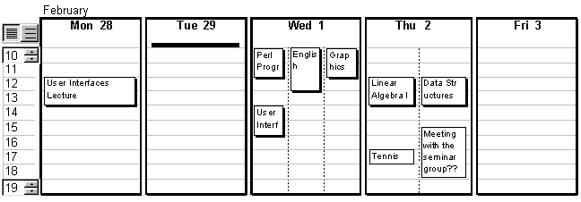
2.2 Schedule
Figure 2.1
Schedule is a flexible calendar view that can be intuitively and directly manipulated by the user. Schedule pattern design emphasizes maximal visibility and direct manipulation of events and the time range: everything can be edited in place. In the design, special care has been taken in solving the problem of showing simultanious events. Drag and drop of event objects is also supported.

2.3 Timeline
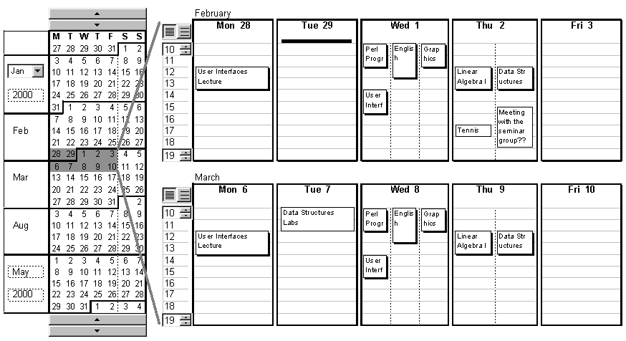
Figure 2.2
Timeline introduces an advanced scrollbar in order to manage time intervals. Although, our intension is to use Timeline with Schedule, the design of the pattern allows the use of Timeline independently. Timeline works best with short time slices, up to six months.

The thumb of the Timeline scrollbar (the dark grey rectangular area in fig 2.2) can be dragged with the mouse to another position. The size of the thumb can be directly incresed or decreased by dragging its borders with the mouse.

The user is able to change the range of the Timeline scrollbar by editing the months and years in the ends of the scrollbar.

3 User Interface Requirements

{Tähän tarkka kuvaus käyttöliittymän vaatimuksista}

{kuvat tänne!!!}

4 Functional Requirements

{Termi Functional Requirements esiintyi englannin kielisissä vaatimusm.}

4.1 Use Cases of Schedule {Operational Scenarious?!}

4.2 Use Cases of Timeline

5 Implementation Requirements

5.1 Schedule

5.2 Timeline

6 Specific Requirements

6.1 Documentation

Due to the possibility that the documentation and code of TIDE may be used outside of the University of Helsinki, all external documentation will be done in English.

Internal documentation such as memos of project meetings may be done in Finnish.

7 Testing Requirements

8 References
The Department of Computer Science, University of Helsinki, does reserch on reusable
terminologia:

Use case == Operational Scenarious

Toiminnalliset vaatimukset = Functional Requirements

www linkit:

http://csdl.ics.hawaii.edu/techreports/98-06/98-06.html#introduction

http://www.gsccca.org/rfp/network.html#_Toc380141680

http://www.dur.ac.uk/~dcs8s00/phases/require.html

